**QGIS**

**27th & 28th January 2015**

# What is a GIS?

A geographic information system, or GIS, is a computerized data management system used to capture, store, manage, retrieve, analyse, and display spatial information. Ecologists and environmentalists use this technique to describe, understand and interpret spatial data.

*When using GIS, it’s important to keep a LOG of each tool you use and each process you go through to get your outputs.

GIS merges cartography with relational databases: data are stored as layers and are linked/related. GIS’ underlying relational database allows complex data to be captured, stored, viewed at different scales and coordinate systems, analysed, understood and used to make predictions. GIS is a good way to represent data visually to explain things to stakeholders, e.g. in nature reserves you have rangers, wardens, business owners, farmers, tourism organisations, construction workers…

# The basis of maps

Maps have an XY coordinate system (a Cartesian system), which is made up of *meridians* and *parallels.*

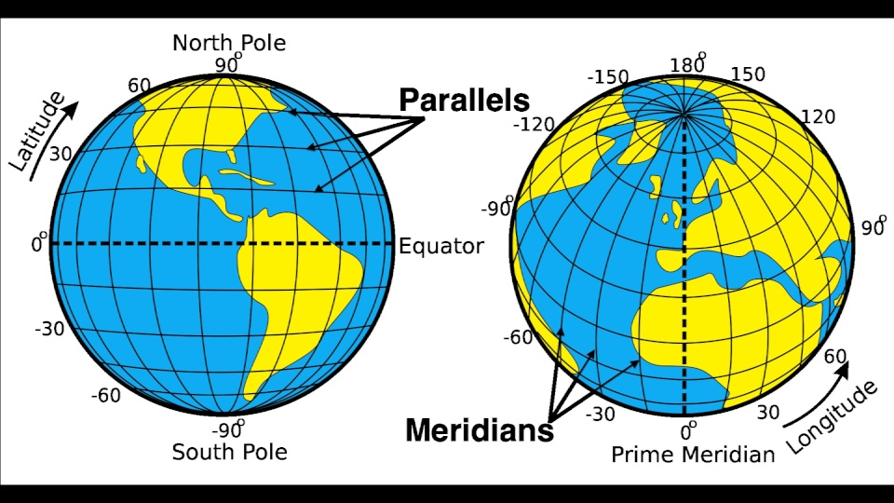

### Map projection

The process of pasting a 3D surface on to a 2D map creates distortion and leads to errors in distance measurements. The solution is MAP PROJECTION: maps are adjusted to display 3D surfaces correctly. This is done based on the process of using a light inside a globe to project the image onto a piece of paper around the outside of the globe. Different shapes and angles of paper can be used for different types of projection:

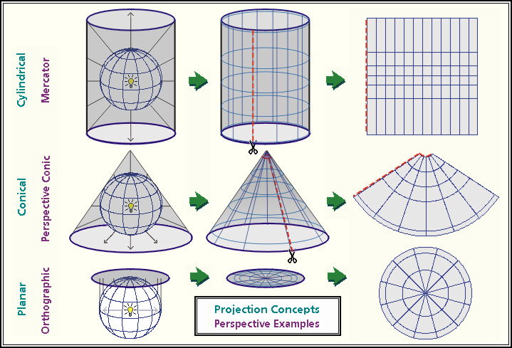

### Datum

The earth is not perfectly round, but slightly ellipsoid. Which creates map projection problems at the poles:

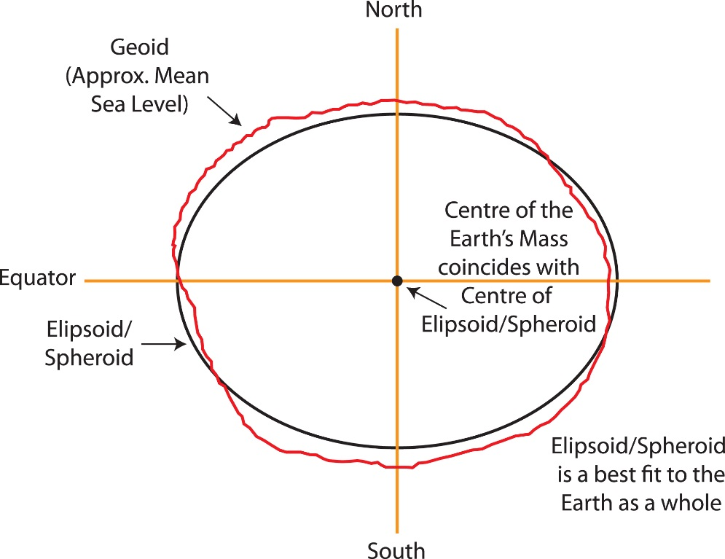

# Using GIS in practice

1. Draw a map to visualise data
2. Think of and ask spatial questions based on this visualisation, e.g.

Question location effects: show locations with/without legal protection

Question condition effects: show species richness at different locations

Question trends: show population declines in different locations

Question patterns: annual/seasonal trends.

## Ways to store GIS data

Geodatabases Data are stored in a central database which many users can access, but not necessarily change or edit, e.g. university-wide databases which different users add different layers to.

Project databases All layers are created in a single project that is less widely accessible by other users.

## Types of GIS data

**Vector Data**

Points, lines and polygons, each with an X and Y coordinate and an ID number.

Points: single points.

Lines: a series of *nodes* (points you click to show where the line should go) connected by *vertices.*

Polygons: connected lines to form a closed shape (also formed by clicking nodes).

**Raster Data**

Series of pixels in a grid system, where data are represented by values arranged in columns and rows.

**Topology**

Records in *hidden* tables, of relationships between features, e.g. connectivity of line features – distances, angles. Each time you move or add anything in GIS, the topological tables are recalculated and updated, which can *take time.*

**Shapefiles**

These contain vector data (points, lines and polygons) and are how most layers are stored. These can be transferred between computers and systems.

**The database**

Contains attributes for each point, row, line etc. in the GIS. E.g. age, shape, city, year.

## Data sources

* Import (buy) from an online geodatabase (e.g. Ordinance Survey, Digimap…)
* Download from a satellite (satellite images = *raster data*)
* Google earth
* GPS units
* XY coordinates from a textfile.

**Satellite images as data**

Each pixel in the image is a reflectance number, e.g. 12, indicating how reflective that block of surface is. Images are recorded in bands, according the the electromagnetic spectrum. Combining the red, green, blue etc bands produces a single colour image. Can be various resolutions – 30m to 2cm. Higher resolutions are more expensive.

Consider time of year when images were taken – e.g. when using images to show habitat distribution.

If doing habitat distribution, need to sample the study site and match colours in satellite image to habitat type. Can use GIS to select random sampling sites. Then input habitat data to GIS and extrapolate to predict the habitat cover in the rest of the study site, using the satellite image.

Can also look at changes in reflectance over time – e.g. seasonal/annual changes in habitat type. Note that these changes can’t be *quantified* by GIS alone and are merely visual when studied in this way.

## Familiarising with the QGIS interface

Add data buttons are found along the LHS, data/view manipulation buttons including zoom tools) along the top bar and map information including scale and coordinate system at the bottom.



The Layers panel acts like the table of contents. If you accidentally delete a layer from here, you can re-add it using the Add Layer button on the LHS panel. When you create a shapefile, 5 separate files are created (each with the same filename but a different suffix: .dbf, .prj, .qpj, .shp and .shx), so to re-load (or add) a shapefile, you need to open the file with the **.shp** suffix.

*Note that all 5 files are required for a shapefile to display correctly, so if you need to move QGIS files around in your My Documents folders, be sure to copy all 5 and not just the .shp.

The Layer Order panel allows manipulation of the order in which layers are drawn/displayed on the canvas.

To add or remove panels, such as the Layers, Layer Order and Processing Toolbox, go to VIEW > PANELS > Select panels to show.

## Setting up the canvas

1. Open QGIS and save the empty project as an appropriate filename.
2. Set the coordinate system: SETTINGS > OPTIONS > CRS (coordinate reference system)
   1. **Projected** CRS vs Geographic CRS (not projected)
   2. Select Europe_Albers_Equal_Area_Conic (ESPG 102013)
   3. Press OK
   4. Select 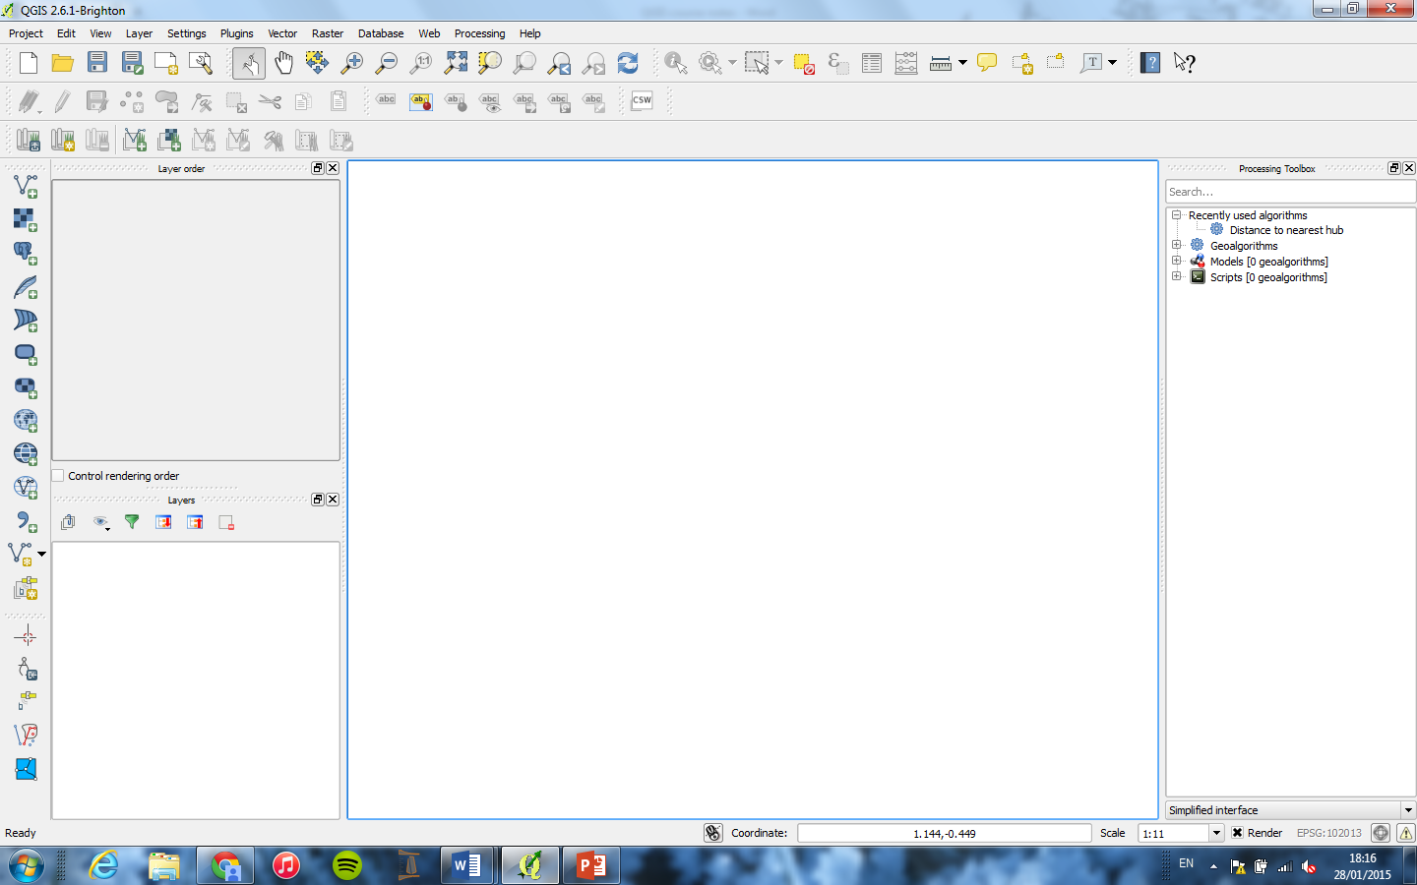 button at bottom right of screen to set the coordinate system for the current map (sometimes it gets changed when you import a new raster map). The current coordinate system will be shown next to this button, e.g. ESPG ######.
3. Set up the plugins
   1. PLUGINS > MANAGE AND INSTALL PLUGINS > Open Layers plugin (if not yet loaded in).

## Adding maps to a QGIS project

**Adding a ready-made (raster) map from within QGIS, using a plugin (needs internet access)**

1. WEB > OPEN LAYERS PLUGIN > BING MAPS > BING AERIAL
2. Click zoom button and zoom to the area of map required (as tight as possible to give the most accurate scale)
3. Check the ESPG number at the bottom of the canvas and re-set the coordinate system if necessary.

*Aerial maps are simply images with no relational information, so this are not a ‘GIS’ yet – to save as a GIS, right click the map in Layers > SAVE AS > shapefile.

**Sources to get maps online**

* Digimap - free
* Avon Wildlife Trust – probably free for students (if you credit them on posters/work)
* Ordinance Survey – select area required to get a quote, then can download or get on disc
* United States Geological Survey (USGS) website: <http://www.usgs.gov/pubprod/>
  + Earth Explorer: <http://earthexplorer.usgs.gov/>
    - Register to say why you want the data – research, student etc
    - Zoom to area of map required and select it using 4 points, one at each corner
    - Can search for images taken within specific dates (e.g. for seasonal habitat comparisons)
    - Can view a Footprint – visualise different blocks of the map
    - Download as a GEOTIFF (image file saved in a raster file format)

**Add downloaded GEOTIFF maps to your QGIS project** (“Training project 2 – Rasters”)

1. ADD RASTER button on LHS button panel
2. Add in the Geotiff files
3. If you added more than one adjacent image, there may be a line between them, owing to a rendering issue: within each raster (image), pixels are coloured in different shades between a specified range, e.g. [0-250] or perhaps [43-279]… ensure both images use the same range, so are rendered on the same scale.
   1. Double click the raster layer in Layers panel > STYLE >
   2. Change border render type to Singleband Psuedocolour
   3. Select desired colour scheme in Generate New Colour Map
   4. Settings:
      1. Mode: Equal Interval
      2. Classes: 50
      3. Min: 0 Max: 250
   5. Press CLASSIFY
   6. APPLY & OK
4. To merge 2 (or more) imported raster images together in to the same file
   1. From the top bar/ribbon, select RASTER > MISCELLANEOUS > MERGE
      1. Input files: select the files to merge (the .tif files)
      2. New output file: browse to required save location for new file and enter appropriate new filename, e.g. MergedImage
      3. OK to run the script
      4. CLOSE to close the window (or you’ll run it again!)
      5. Then re-classify the rendering (double click the new merged shapefile ‘MergedImage.shp’ and adjust the style as above, remembering to click CLASSIFY, APPLY & OK.

**Add/import an Ordinance Survey map file (that you have downloaded)** (“Training project 3 - OS”)

1. Click button on LHS panel ADD VECTOR LAYER
2. Select file to import, e.g. ‘SO81NW.GZ’

## Creating new vector layers in a QGIS project (“Training project 1”)

1. Create an empty shapefile (a new map layer to add some points):
   1. LAYERS > CREATE LAYER > NEW SHAPEFILE (or use button on LHS panel)

This opens a window entitled ‘New Vector Layer’

* 1. Select shapefile type (point, line or polygon)
  2. Browse to the folder you want to save in and save the new layer as an appropriate filename, e.g. “Points.shp”
  3. OK

The new shapefile will appear in the Layers panel.

1. Manually add some features to the new shapefile
   1. Select the shapefile by clicking on it in the Layers panel
   2. TOGGLE EDITING on using the button at the top left of the canvas
   3. Click the ADD FEATURE button
   4. Left click on the canvas to place points (or lines/polygons – right click to end the line/polygon)

*If an error appears after clicking each point, go to SETTINGS > OPTIONS > DIGITIZING > Check the box next to SUPPRESS ATTRIBUTE FORM POP-UP AFTER FEATURE CREATION.

* 1. To adjust a feature are buttons to move, rotate etc
  2. There are also buttons to add labels
  3. TOGGLE EDITING off and save edits.

1. Control rendering order
   1. Toggle CONTROL RENDERING ORDER on (below the Layer Order panel) and drag layers in the list to reorder how they are displayed on the canvas.

## Editing the style (colour) of layers

1. Double click the layer in the Layers panel
2. Select **STYLE**
3. Double click Simple Fill (for a line or polygon layer) or Simple Marker for a points layer
4. Edit stuff – e.g. fill colour or lines
5. Use drop-down list in top left of the window to change between Single Symbol, Categorized and Graduated to alter how the layer is coloured. E.g. for habitat mapping, categorized would be useful (i.e. select colour by field ‘Habitat Type’). Or for soil moisture levels, graduated would be better (i.e. select colour by field ‘Soil Moisture’).
   1. Select the colour system to use, e.g. blues, random colours…
   2. Click CLASSIFY to list the colours for each category/range
   3. APPLY & OK
6. To change symbol shapes for point layers, double click on Simple Marker and from the drop-down list for Symbol Type (top right), select SVG Marker to display more symbol shapes.
7. Below the Style tab there is one for **Labels**, where you can switch on labels for each point/line etc: ADD LABELS > Select label names to use from the drop-down list, e.g. ‘ID’ > APPLY & OK.
8. You can save styles (as .qml files) or download saved styles, e.g. OS colour palette or Phase 1 habitat survey colour palette, and then load these saved styles into your project to use for colouring different road types and terrain types (fields, beaches) **consistently** between separate layers and projects.
   1. E.g. in an OS map, to colour areas using the standard OS style, double click the OS map vector layer in the Layers panel (in this case, Area), go to STYLE, click the button LOAD STYLE, navigate to the file location where the .qml file for the map is saved (in this case, QGISDATA/OSGloucester/Area.qml) and click to load the colour palette. Same for RoadCLine > load the file roadcline.qml (to colour by road type).

**Add a delimited text layer (a .csv file)**

1. Press button on LHS panel to Add Delimited Text Layer
2. Browse to the file location and select the file to import
3. Select the X and Y fields and whether the file is a CSV or otherwise
4. If ‘No Coordinate System on Import’ is selected, QGIS will assume the file’s coordinate system (CS) is the same as the current canvas.
5. Once the file is imported, it is not yet a GIS (not part of the relational database yet) – you need to save it as a shapefile: right click the layer in the Layers panel, SAVE AS > Browse to the required saving location and enter a new filename > OK
6. Check the attribute table of the new shapefile: right click > OPEN ATTRIBUTE TABLE and look at the columns to check they are all present (including an ID number for each row, which should have been in the .CSV file already)
7. Then delete the .CSV file from the Layers panel.

**The Clipper tool** (“Training project 4 – ReservePoly”)

Used to select a smaller area of a large map to work on in detail. Used to make maps look clearer and neater and also for extracting data to use in MAXNT – free software for spatial analysis of species distribution data.

1. From the top bar/ribbon, select RASTER > EXTRACTION > CLIPPER > drag over the map
2. Then re-classify the rendering (via Style) and change colours to make the clipped area stand out from the original merged raster file (e.g. colour the clip and keep the base raster in black and white).

Working with the Clip

There are several tools that can extract terrain features from **rasters** to improve map detail. Terrain features like slope can also be used as explanatory variables in multivariate models of e.g. species distribution or abundance.

Draw contour lines to describe the terrain

1. From the top bar/ribbon, select RASTER > EXTRACTION > CONTOUR
2. Input file: Clip
3. Browse to required saving location and enter new filename
4. Enter required distance between contours (in meters) – default is 10, could use 25 for a clearer/less cluttered map. Lower numbers mean lines closer together (higher resolution) but will be slower to draw.

Calculate the steepness of slopes (creates an index of slope in degrees)

1. From the top bar/ribbon, select RASTER > TERRAIN ANALYSIS > SLOPE
2. Elevation layer: Clip
3. Output file: browse to required saving location and enter new filename
4. Z = the conversion factor, so units of rate of change of X with Y, working in angular degrees. Keep the default.

Show the aspect of each slope (whether they are north/south facing) in 0-360 degrees

1. From the top bar/ribbon, select RASTER > TERRAIN ANALYSIS > ASPECT
2. Elevation layer: Clip
3. Output file: browse to required saving location and enter new filename

*Note that when using degrees for analysis you can’t use 0-360° (10° and 350° degrees are very close on the compass, but the numbers won’t be interpreted like this) so will have to use the function RECLASSIFY: brings up a text file where you write each original value (0-360°) and the values to convert them to (0°-180°-1°, i.e. 350° will become -10; 340° will become -20 etc.

Show the hill shade on each slope – according to where the sun is at a specified time of day

1. From the top bar/ribbon, select RASTER > TERRAIN ANALYSIS > HILLSHADE
2. Elevation layer: Clip
3. Output file: browse to required saving location and enter new filename
4. If wanted, change the angle of the sun for morning, night etc.

Calculate an index of terrain ruggedness

1. From the top bar/ribbon, select RASTER > TERRAIN ANALYSIS > RUGGEDNESS
2. Elevation layer: Clip
3. Output file: browse to required saving location and enter new filename

## Create a sampling system for a study area (“Training project 4 – ReservePoly”)

To select grids within a specific area within which to sample e.g. habitat type or count species.

1. Start with a ‘study area’ saved as a polygon, e.g. the outline of a reserve area (a.k.a ‘Reserve-poly’).

To draw a grid over the clipped reserve polygon

1. From the top bar/ribbon, select VECTOR > RESEARCH TOOLS > VECTOR GRID
2. Grid extent: area to create the grid over (use ‘reserve-poly-clipped’)
3. Click UPDATE EXTENTS FROM LAYER
4. Enter the required grid size next to X (e.g. 1500. Scale is metres by default)
5. Select OUTPUT GRIDS AS POLYGONS
6. Output file: browse to required saving location and enter new filename
7. OK

To select regular points (selects central point in each grid cell)

1. From the top bar/ribbon, select VECTOR > RESEARCH TOOLS > REGULAR POINTS
2. Input boundary layer: reserve-poly-clipped
3. Select number of points to select (or alternatively, point spacing)
4. Output file: browse to required saving location and enter new filename
5. OK to run the script, then CLOSE.

To select random points (selects specified number of random points within the grid)

1. From the top bar/ribbon, select VECTOR > RESEARCH TOOLS > RANDOM POINTS
2. Input boundary layer: reserve-poly-clipped
3. Select number of points to select across entire grid (unstratified sampling), OR select point density, e.g. 5 random points per cell (stratified sampling) *THIS SEEMS TO CRASH QGIS!! Try smaller number of points per cell?
4. Output file: browse to required saving location and enter new filename.
5. OK to run the script, then CLOSE.

*Stratified sampling can lead to over- or under-sampling the grid squares around the edges of the polygon, which may not be as big as the inner grid squares. To avoid this, use the CLIP tool to ‘cookie-cut’ the reserve polygon out of the grid (From the top bar/ribbon select VECTOR > GEOPROCESSING TOOLS > CLIP > Input (base) layer: ‘nameofyourgrid’, Clip (cutter sized) layer: ‘reserve-poly’). Then when you ask QGIS to select random points at a specific (stratified) density, it will calculate the area of each partial-grid square around the edges of the clipped polygon and work out the number of points to select in each partial grid cell according to its total area (i.e. if a cell is only 20% of the size of a complete grid cell, QGIS will only select 1 random point in that cell, instead of 5.).

To select random grids (within which to sample in the field):

1. From the top bar/ribbon, select VECTOR > RESEARCH TOOLS > RANDOM SELECTION
2. Select number of grid squares to select
3. OK
4. The required number of grid cells will be highlighted in yellow (and in the attribute table too)
5. To deselect, press button on top bar to ‘deselect all’.

## Adding fields to layers’ attribute tables ((“Training project 4 – ReservePoly”)

**Calculating Area**

1. Right click on the layer you want to work with (i.e. ‘reserve-poly-clipped’) and open the attribute table
2. TOGGLE EDITS on at the top, then click the FIELD CALCULATOR button
3. Create a new field: “AreaOfGridSq”
4. Output field type: “Decimal Number” – specify field size (bigger is better as can fit more digits) and precision (number of decimal places – don’t go too high as sometimes this interferes with calculations, e.g. they become negative! 2-6 decimal places works).
5. Scroll down the function list to Geometry > double click $area and it will appear in the bottom expression builder.
6. Click OK and it will calculate the area of each polygon (grid cell) and enter it in a new column called “AreaOfGridSq” in the attribute table of the selected layer.
7. TOGGLE EDITING off and save edits.

Now you can select grids/points by expression:

1. Highlight the layer you want to select from in the Layers panel
2. From the top bar/ribbon, select VIEW > SELECT > SELECT BY EXPRESSION
3. Under Fields and Values, double click on the field to select by, e.g. ID/Length/Area and it will appear in the bottom expression compiler
4. Under Operators, select the function: < > / * etc. For example, build the expression “Area” > 1000 to select all the grid squares (polygons) with an area greater than 1000m2)
5. Then OK
6. This will select the points/features that fit that criteria on the map and in the attribute table of that layer.

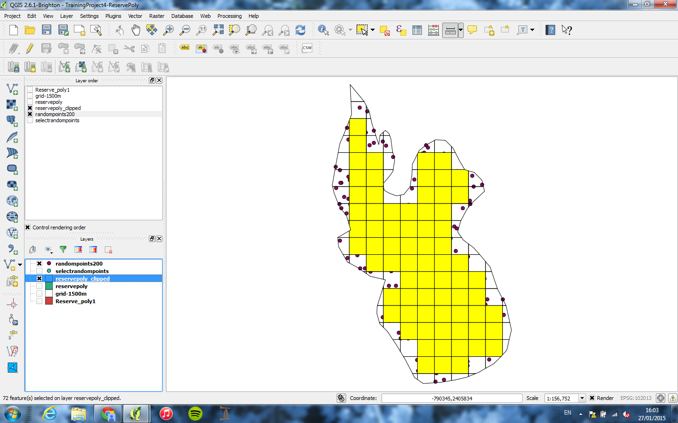

1. Deselect using button on top bar.

**Counting the numbers of points within a grid square**

This will be saved in a new layer called e.g. ‘Count’. Then you can add an Area field to this layer’s attribute table and from this calculate Density.

1. From the top bar/ribbon, select VECTOR > ANALYSIS TOOLS > POINTS IN POLYGONS
2. Input polygon: ‘reserve-poly-clipped’
3. Input point vector: your points layer, e.g. ‘randompoints200’ or ‘nestlocations’
4. Enter a new field name for the counts column
5. Output file: browse to required saving location and enter new filename.

**Calculating density**

1. Create a counts layer using the above procedure
2. Add an Area field to the counts layer using the field calculator
3. Open the attribute table of the counts layer
4. TOGGLE EDITING on, open the Field Calculator
5. Enter the new field name: “Density”
6. Field length: 10 / Precision: 6
7. Scroll to Fields and Values, select ‘Count’ and ‘Area’
8. Scroll to Operators: place a / between Count and Area
9. Toggle edits off
10. OK
11. This creates a new field in the counts attribute table called Density.
12. Edit the style of the counts layer to ‘graduated’ fill colour based on the Density field to better visualise the data (if wanted).

**To export data to Excel for stats**

1. Open the attribute table
2. Select all
3. Ctrl+C
4. Open Excel and Ctrl+V to paste in. Then delete unwanted columns.

**To export a map to a PDF or image file for printing and publishing**

1. From the top bar/ribbon, select PROJECT > NEW PRINT COMPOSER
2. This opens a new window where you can adjust your map, add a legend, labels, scale bars, compasses etc.
3. To paste in your map, click the button on the LHS panel ‘Add New Map’, then draw a square on the canvas to indicate where to paste the map.

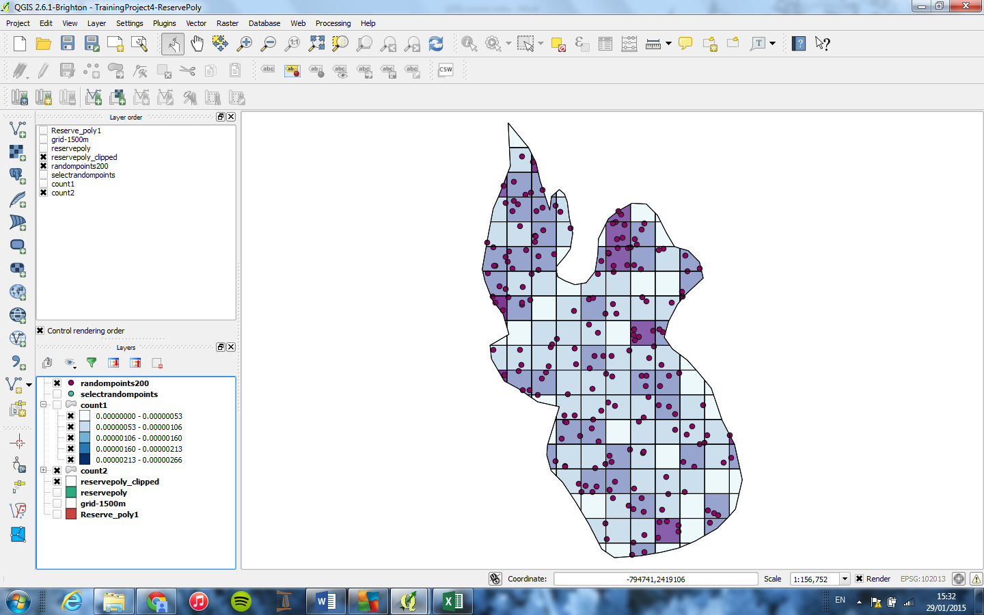

## Species distribution modelling

* The most useful technique for modelling in conservation
* Nowadays use presence only data (not presence & absence, to avoid false negatives).
* The software to use for this is MAXENT <http://www.cs.princeton.edu/~schapire/maxent/>
  + Has been extensively tested on ecological data
  + Easy to use
  + Has model evaluation functions
  + GIS provides the variables it requires

## Habitat suitability modelling

1. Identify the suitable habitat for a species
2. Map the habitat types and species distribution

**Interpolation: filling in missing values using best guess** **(“Training project 5 – Orchids”)**

Soil moisture levels were recorded at different locations. Interpolation can be used to estimate moisture levels at locations where it was not recorded in the field, using measurements from the surrounding grid squares. This can be used to see which soil moisture levels support the most orchids.

**Set up the project**

1. New project
2. Click the button ADD VECTOR in the LHS panel. add the file ‘reserve-poly.shp’ to add the reserve boundary.
   1. Change the style to have a transparent fill
3. Add Delimited Text File button > Soil moisture (‘moisture-1’) & save as a shapefile.

**Interpolate the soil moisture across entire reserve area**

1. From the top bar/ribbon, select VIEW > PANELS > TOOLBOX to show the processing toolbox.
2. Search for the tool Grid Interpolation in the toolbox (NB. this tool always creates a square grid)
3. Input: ‘moisture-1’
4. Output: ‘interpolated-moisture.tif’ (creates a new raster file)
5. Check the Z field box (selects the values to do the interpolation of) and choose the data field ‘value’ within the ‘moisture-1’ layer’s attribute table.
6. OK
7. This creates a smaller-scale ‘grid’ of moisture levels (called ‘interpolated-moisture’)

**Clip the interpolated moisture levels to show only the soil moisture levels within the reserve boundary.**

1. From the top bar/ribbon, select RASTER > EXTRACTION > CLIPPER
2. Name as ‘interpolated-moisture-clipped’
3. Clipping mode: mask layer (you can’t clip to a shape if you’re using a raster layer (but can with a vector layer); rasters always stay square. So you have to just mask the outer part.
4. Add to canvas
5. This turns the area outside of the reserve boundary (polygon) to zero (and goes black), so the interpolation won’t run in these grid squares. You can change the colour of the mask to white so it doesn’t show on the canvas, using STYLE > SINGLE PSUEDOCOLOUR.

**Make a 1500m grid over entire map (to calculate areas and densities)**

Follow instructions on p.10 to draw a grid and name it as ‘interpolated-moisture-grid’.

**Clip out the grid into the shape of the reserve (to calculate areas and densities)**

1. From the top bar/ribbon, select VECTOR > GEOPROCESSING TOOLS > CLIP
2. Input vector layer: ‘interpolated-moisture-gid’
3. Output file: browse to required saving location and enter new filename ‘interpolated-moisture-grid-clipped’

**Add orchid count data (a points vector) to the canvas**

1. Click the button Add CSV File on LHS panel and add the file ‘Green Winged Orchid Survey’
2. Right click the layer and save as shapefile ‘Orchid-survey-data’
3. Delete the CSV file from the Layers panel

**Calculate orchid density across the reserve**

1. Count the orchids: from the top bar/ribbon, select VECTOR > ANALYSIS TOOLS > POINTS IN POLYGON
   1. Save output as ‘count-of-orchids’
   2. Check the attribute table of the new layer ‘count-of-orchids’
2. Do zonal statistics to summarise habitat zones
   1. Zonal statistics work on raster datasets: can show the mean/median soil moisture in a specified set of grid squares
   2. From the top bar/ribbon, go to RASTER > ZONAL STATISTICS
   3. Raster layer: ‘interpolated-moisture-clipped’ (the interpolated layer of moisture)
   4. Polygon containing the zones: ‘interpolated-moisture-grid-clipped’ (the 1500m grid)
   5. Output column prefix: ‘moist’ (the word to start each new column created with – this function doesn’t create a new file, but adds a series of new fields/columns to the file ‘interpolated-moisture-grid-clipped’, i.e. the polygon layer containing the zones).
   6. OK
   7. Open the attribute table of ‘interpolated-moisture-grid-clipped’ to see the new fields starting with ‘moist-‘ that show the zonal summary statistics.

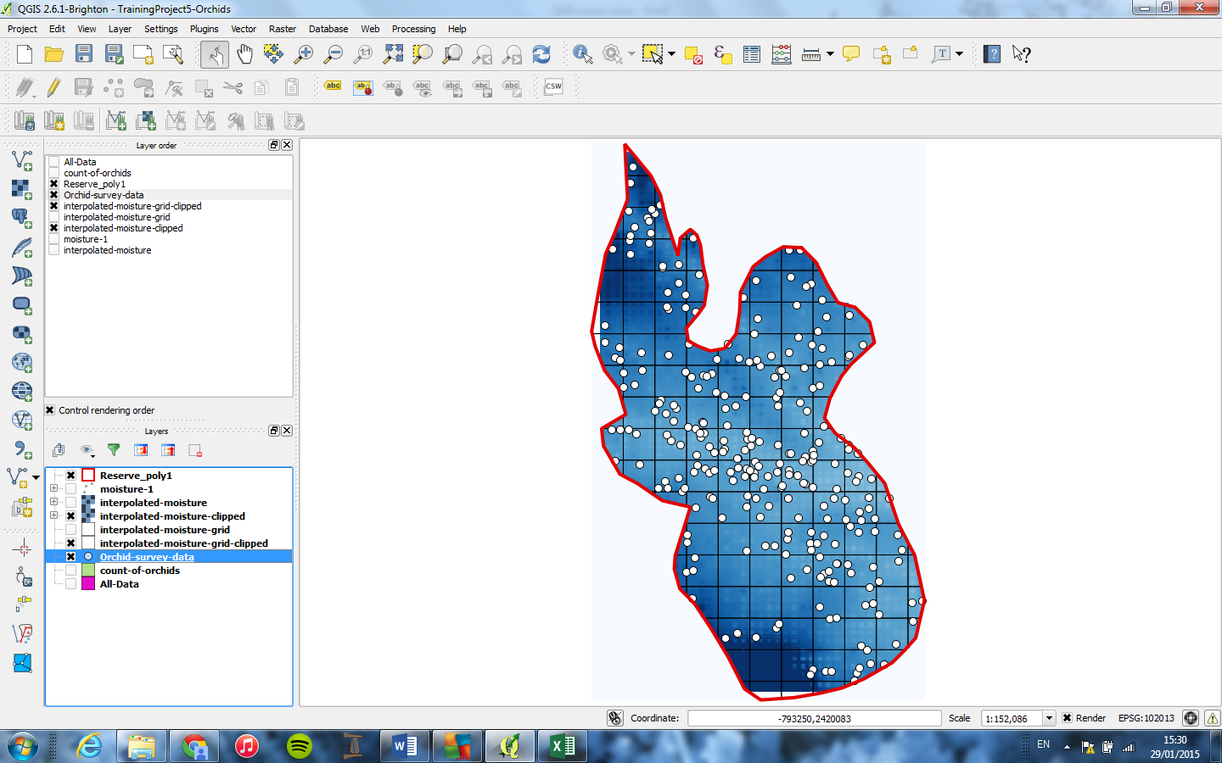

1. Moving columns between files/layers’ attribute tables
   1. This is done by creating a JOIN, based on a spatially referenced point, e.g. a grid square/zone.
   2. From the top bar/ribbon, select VECTOR > DATA MANAGEMENT TOOLS > JOIN ATTRIBUTES BY LOCATION
   3. Target vector layer: ‘counts-of-orchids’
   4. Join vector layer: ‘interpolated-moisture-grid-clipped’
   5. Output shapefile: browse to required saving location and enter new filename ‘All-Data
   6. Tick the box for KEEP ALL RECORDS
   7. OK
   8. Look in the attribute table for ‘All-Data’
   9. TOGGLE EDITING on
   10. Press the DELETE COLUMNS button to remove any unwanted columns (careful!)
   11. TOGGLE EDITING off and save
2. Calculate density
   1. Open All-Data
   2. TOGGLE EDITING on
   3. Open the Field Calculator
   4. Make a column for Area (Geometry > $area) (adjust field size and precision)
   5. Make a column for Density (adjust field size and precision):

(“count-of-orchids” / “Area”) * 1,000,000

Multiplying the answer by 1 million converts the units from m2 to km2

* 1. TOGGLE EDITING off and save

1. Copy and paste the attribute table in to Excel (or other program) to do some stats

**Do a regression analysis in Excel**

To determine whether soil moisture levels explain orchid density.

1. Import the data from QGIS (by copy and pasting from the attribute table)
2. Keep only the columns for (zonal-)soil moisture and orchid density
3. Plot a graph of density (y) against moisture (x) and add a trend line
4. In the Data tab in the Excel top ribbon, press the button for Data Analysis (far right)
5. Select the Regression function
   1. Y: density column
   2. X: soil moisture column
   3. Output: select any empty cell to be the top left corner of the regression output tables
6. Interpret the output: Excel calls the slope the ‘x-variable’ and it is the P Value on this row that you want.

## Habitat selection modelling (“Training Project 5 – HabitatSelectionModelling”)

To do this, you create a buffer zone around each location (e.g. birds nest, tree, orchid, goose) and calculate the *proportion* of different habitat types present within each buffer zone, e.g.:

|  |  |  |  |
| --- | --- | --- | --- |
| Buffer zone ID | Habitat type 1 (%) | Habitat type 2 (%) | Habitat type 3 (%) |
| 1 | 60 | 10 | 30 |
| 2 | 70 | 15 | 15 |

1. New project
2. Add vector > ‘reserve-poly’
   1. Make fill transparent (via. Style)
3. Add vector > ‘habitat’
   1. Change fill to ‘categorized’ by habitat (via. Style)
4. Add some points wherever to represent species presence
   1. Create a new empty shapefile (from the top bar/ribbon, select LAYER > CREATE LAYER > Point > Save output as ‘Birds-Nests’)
   2. Select the new point layer ‘Birds-Nests’ in the Layers panel and click TOGGLE EDITING on at the top left of the canvas. Click Add Feature and click some ‘nests’ on the map. TOGGLE EDITING off and save edits.
   3. As this is an artificially-made shapefile, the added points won’t automatically have ID numbers. Open the attribute table for ‘Birds-Nests’, TOGGLE EDITING on and enter ID numbers 1-10 or whatever in the column. TOGGLE EDITING off and save.
5. Draw the buffers around the nests
   1. From the top bar/ribbon, select VECTOR > GEOPROCESSING TOOLS > BUFFER
   2. Input vector: ‘Birds-Nests’ (layer to be buffered)
   3. Segments to approximate = 20 (QGIS draws circles with straight lines, like hexagons, so the more segments the smoother/more ‘rounded’ the line appears)
   4. Buffer distance: 2000m (distance to draw the buffer from the centre, i.e. radius
   5. Output file: browse to required saving location and enter new filename ‘Nest-Buffer’
6. INTERSECT TOOL – to intersect overlapping buffers (otherwise overlapping buffers would be summed/conjoined together as a single buffer zone, and habitat proportions calculated across the entire conjoined area, skewing the results)
   1. From the top bar/ribbon, select VECTOR > GEOPROCESSING TOOLS > INTERSECT
   2. Input vector layer: ‘habitat’
   3. Intersect layer: ‘Nest-Buffer’
   4. Output file: browse to required saving location and enter new filename ‘Nest-Buffer-intersect’
   5. OK

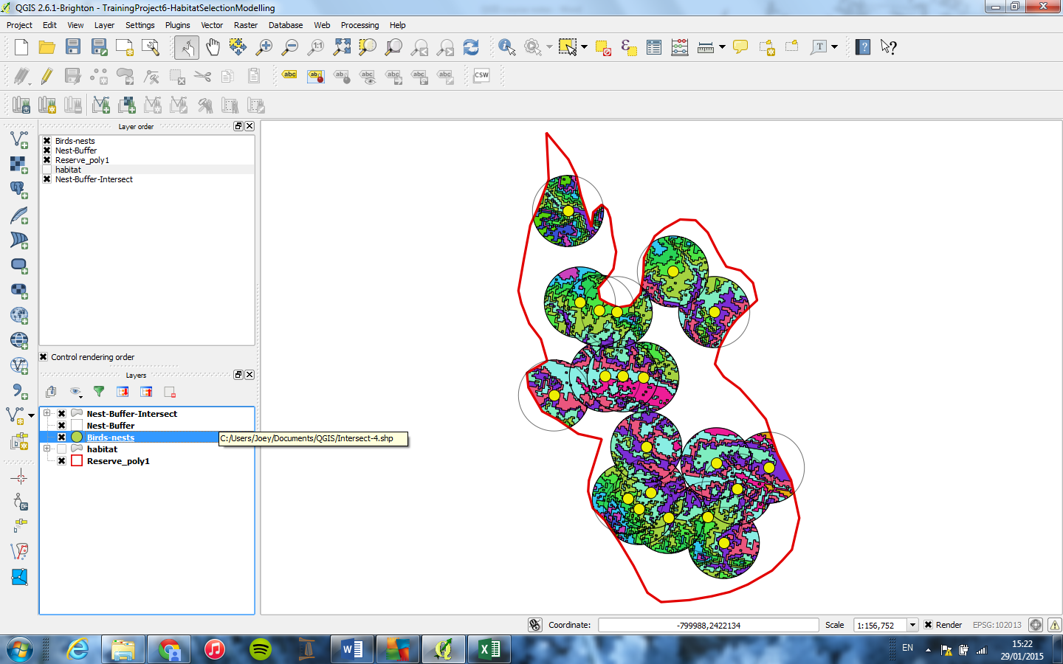

1. Calculate the area in each buffer zone
   1. Open ‘Nest-Buffer-Intersect’ attribute table
   2. TOGGLE EDITING on
   3. Open the Field Calculator
   4. Create a column for Area (adjust field size and precision)
   5. TOGGLE EDITING off
2. Copy and paste the data into Excel
   1. Keep columns for habitat type, nest buffer ID number, area.
   2. Use Excel’s PivotTable function to display table totals more clearly – allows to calculate mean habitat coverage, most common habitat types etc.:
      1. INSERT tab > RECOMMENDED PIVOT TABLES > select BLANK PIVOT TABLE to bring up a side-panel for making Pivot tables
         1. Drag Habitat type into Column
         2. Nest-Buffer into Row
         3. Area into Values
      2. View the table!

## Measuring neighbour distances

This technique can be used to answer questions about e.g. the effects of disturbance (i.e. distance from a road or path) on animal behaviour.

Task: do geese cluster together when they are foraging closer to a footpath, and therefore experiencing a higher level of disturbance?

1. New project
2. Change the scale at the bottom of the canvas to 1:2500
3. Add a new empty Line shapefile
   1. Draw a horizontal line on canvas to represent the path, called ‘line-path’
4. Add a new empty polygon shapefile
   1. Draw a polygon adjacent to the path, to represent the field, called ‘feeding-area’
5. Add ~200 random points on the polygon, to represent foraging geese
   1. From the top bar/ribbon, select VECTOR > RESEARCH TOOLS > RANDOM POINTS
   2. Input boundary layer: ‘feeding-area’
   3. Output file: browse to required saving location and enter new filename ‘goose-distribution’.

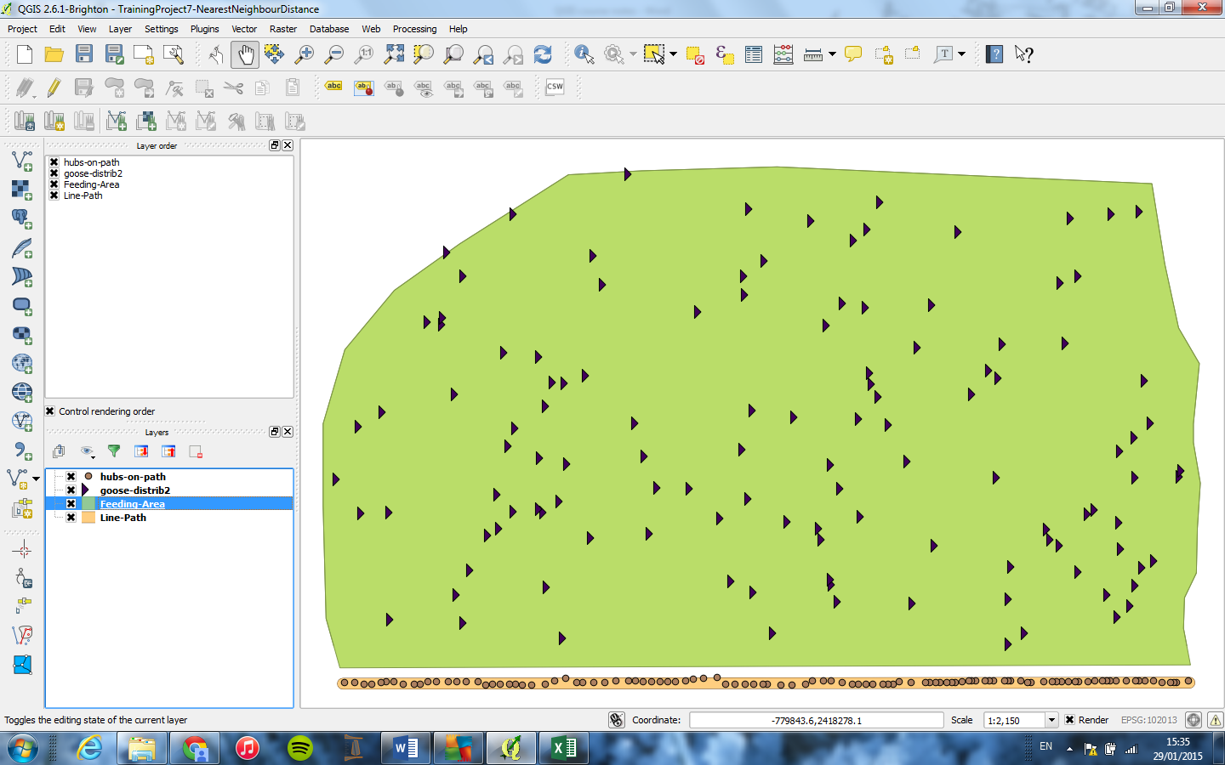

1. Calculate nearest-neighbour distances between the geese
   1. From the top bar/ribbon, select VECTOR > ANALYSIS TOOLS > DISTANCE MATRIX
      1. Input: ‘goose distribution’
      2. ID field: ‘ID’ field listing IDs of each point/goose in the ‘goose-distribution’ points layer
      3. Target point layer: ‘goose-distribution’
      4. Target unique ID: ID
      5. Tick the box for USE ONLY NEAREST (k) TARGET POINTS, and keep the value at the default (k=1). This means to only measure the distance between the single nearest neighbour of each point. If you change this number to 2, it would measure the distance to the nearest neighbour, and the second nearest neighbour.
      6. The output from this is an Excel file containing the ID of each ‘goose’, the ID of their nearest neighbour and the distance to their nearest neighbour – open this via. My Documents, not in QGIS.
2. Calculate the distance between each goose and the path
   1. Use the tool DISTANCE TO NEAREST HUB
      1. This tool has a glitch: if the ‘hub you want to measure to is a line, the tool sets the ‘hub’ as a single point somewhere around the centre of the line (the exact position depends on the line shape). Thus, the distance from each goose to this point will rarely be the shortest distance to the path. To solve this, create a new empty line shapefile called ‘hubs-on-path’ and click points all along the line/path (as close together as possible).
      2. Then you can use the Distance to Nearest Hub tool, specifying the ‘hubs’ as the points in the ‘hubs-on-path’ layer:
         1. Source points layer: ‘goose-distribution’
         2. Destination hubs layer: ‘hubs-on-path’
         3. The output will be saved to a temporary file, which you can copy and add to the Excel sheet of nearest neighbour measurements (if you order by goose ID, you can match up the values by these ID numbers).

## Geo-referencing imported maps

If you’re not sure which coordinate system to use/which coordinate system the map was drawn in/can’t use a standard coordinate system, you can geo-reference maps by clicking points, to force the image into the coordinate system you want:

1. In the top bar/ribbon, select WEB > BING MAPS > import the map from Bing maps (zoom in as tight as possible for highest possible accuracy)
2. In the top bar/ribbon, select PROJECT > SAVE AS IMAGE > choose suitable filename in My Documents.
3. In the top bar/ribbon, select RASTER > GEOREFERENCER > Open the saved image
4. Click points on the map in the GEOREFERENCER window and then the same corresponding points in QGIS. More points = more accuracy.
5. Then enter the coordinate system you want to use.